Flight Information Display System Using Information and Technology and Machine Learning

Abstract— As per technical terms FIDS is generally a software used for displaying flights related information on big screen. It also works as a media platform for entertainment and other services. Also known as Digital Signage Software, such systems not only allow the passengers to find the terminal and their respective gates but also provides real time information regarding departure and arrival of any aircraft. It also provides real time feedback regarding wind direction, speed and various terminologies related to pressure and thrust. As, it is known that timed information of any data helps in providing the real time navigation with constant support and other facilities so in today's generation these types of innovations can create a huge impact by revolutionizing the way of thinking and the way of acting as per situations by implementing the Concepts OF IOT and Machine Learning.

Keywords— *FIDS (FLIGHT INFORMATION DISPLAY SYSTEM), XAMPP SERVER, OS MODULE (Python module for locating files).*

1. **Introduction**

Although the name suggests that FIDS is basically a software used for real time navigation and treatments used for displaying flight information on a big screen with real time enhancements within an airport premise that shows passengers information about their flights such as live flights etc.

From the birth of this technology till its recent usage it has undergone a lot of changes but still it requires a lot of improvements in order to provide best results to the users with minimum cost and more efficiency.

As, it is seen that modern flight equipment are equipped with advanced technologies including passenger details along with the flight boarding time, gate and many important details digitally, thus making it convenient for the staff members to manage the data according to the details.

[1] “Need of modern technologies for creating modern flight information display system using the concepts of ML and IOT based concepts in the field of Airport security management” because basic principle of Longevity in order to live a healthy and disease-free life a person has to undergo a lot of changes and rules in order to be superior and better from others similarly, this rule is for non-living things also in order to be used forever they have to undergo a lot of changes in order to be productive with minimum cost and labour work. So, in order to deal with these types of problems various technologies with different concepts are introduced with respect to generation to provide maximum efficiency in their task with maximum competition. As it is seen, that flight information display system is a computer system which is used in airports in order to display the records of flights with real time navigation and details in order to go through the system and its resources in an efficient manner in order to manage the flights details and corresponding passenger details in database. Each Line in FIDS represents the different flights with their respective flight numbers in order to manage them in fluent way. For example, in case of flight number E3012 (E3 represents the E3 terminal number and 3012 represents the flight number in order to plan the landing and park them at particular terminals.) Nowadays, in order to manage the flight details in an efficient way TAV (Technologies FIDS) is a smart, digital signage solution that provides an automated system that distributes and displays real time- flight information in display in tabular form in order to manage them efficiently.

Each line in FIDS consists of

Logo and Name of the Airline, City of Origin / Destination and its layovers, Expected Departure / Arrival Time, Any update on time/ arrivals. Nowadays, it is seen that most of the FIDS software and their co-components are built using the concept of TAV technologies then how much secure is this TAB based flight information display system we can infer from this statement by considering this points.

Fast and accurate, 24/7 availability, advanced technologies, well defined technologies with good implementation of machine learning concepts.

* 1. **features of flight information display system**

As today’s era is based on the concept of deep learning concepts and some beneficial ideas in order to facilitate the usage of user’s and their day-to-day tasks. So, in order to deal with it most of the automated systems are made with the help of technicians who are having great knowledge of machine learning concepts with some real time management strategy in order to manage the risks effectively so that no problem can be encountered. Talking about the travelling agencies as well as day-to-day flight information it requires a lot of effort in order to manage the things in effective manner so that they can easily deal with large number of datasets of flights along with proper implementation and management of display board. Nowadays, most of the MNC’s are focussing on creating multilevel companies so that they can easily compete in this technological based era with the help of machine learning based concepts and some good programming concepts of Python, C and Java along with their backend services support in order to deal with the database with proper documentation.

Not only that this feature of FIDS is not only restricted with the flight information display system it also includes some useful features of passenger’s details, flight numbers destination and other coherent details. It also combines the usage of ATC tower along with the FIDS so that all flights and respective details can be easily managed with least chances of disasters. In today’s generation most of the FIDS software is equipped with great security features such as trials settings, maximum login attempts, two factor-authentication and many more in order to prevent hacking of database records.

As we know that most of the flight information is based upon the runway settings so in order to deal with it is better to do the inspection of runway and flight take-off details time to time so that proper maintenance can be provided to it and in case of emergency it can be easily managed.

Main feature to be considered while designing the FIDS software along with some security features:

Two factor authentication for prevention of database records, multi-level security features with login attempts trials, Passcode generation for users in order to prevent the user’s identity with multiple login attempts, System passcode for ensuring the security level of users as well as the system.

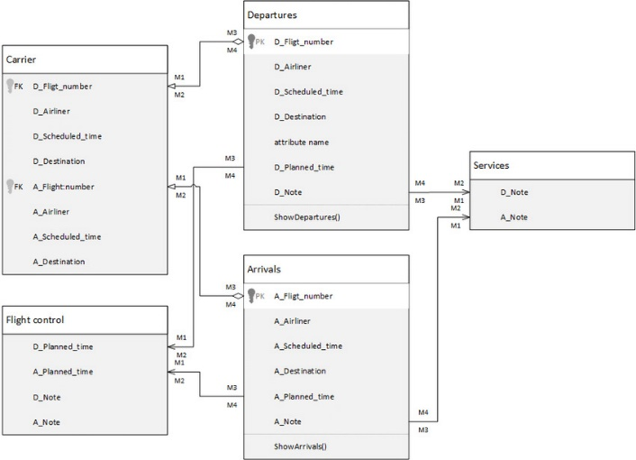

Figure 1: Working principle of Flight Information Display System

As represented in the above diagram, all the users and other facilities requirements are completely dependent on the functioning of ATS tower because it’s the only thing or we can say commutator which is commutating the ground responses to the flight operator and from flight operator to ground station. Not only that it also plays a significant role in managing the estimate time of flight departures and whether they are on time or not so that all the flight operations can be easily managed.

* 1. **RECENT ADVANCEMENTS IN THE FIELD OF FIDS**

As it is known, that today is the era of technological development not any theoretical development so mentioning that in the field of FIDS (Flight Information Display System) there has been a rapid growth in terms of methods and technologies that are used to develop that software as per the requirement of customer and users. Not only that, today TAV technologies is not only restricted with the usage of flight information display system in airports and security authorities today it is trying to make it available to all the customers whosever has that privilege to access that information. At the same time, it is also ensuring the need of security purpose in that software so that in case of any emergency it can be easily handled. TAV based technologies of FIDS now provides improved user experience so that the users as well as employees can experience the amazing feature of editors in single pane of window and can easily adapt towards the changes.

First of all, the most common use of FIDS includes the architecture of RADIO-FREQUENCY DISTRIBUTION/ INDENTIFICATION. Client-Server Model: The system is designed to have two main components - the client and the server. The client is responsible for displaying the flight information to the users, while the server manages the data and serves it to the clients. Distributed System: The architecture allows for the system to be distributed across multiple clients and servers. Each client can fetch information from the server and display it to the users, ensuring scalability and efficiency.

Centralized Data Management: The server is responsible for managing the flight information data. This centralization allows for consistency and easy updates to the information as it is stored and managed in a single location. Request-Response Communication: The client interacts with the server through request-response communication. The client sends requests for specific flight information, and the server responds by providing the requested data. This communication model ensures reliable and timely data retrieval.

Scalability and Reliability: The architecture allows for easy scalability by adding more clients and servers as the system grows. It also ensures reliability by distributing the load across multiple servers and providing redundancy in case of failures.

Overall, the TAVB based Flight information display system follows the Client-Server architecture, which provides a solid foundation for efficient, scalable, and reliable flight information management and display.

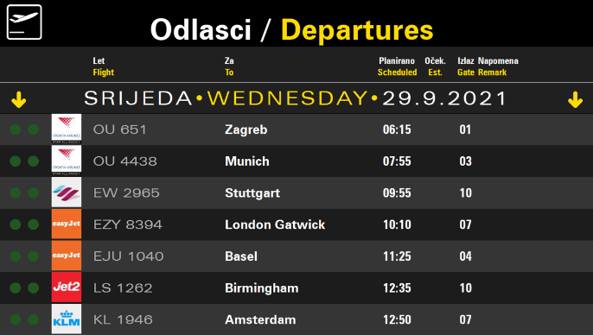

Figure 2: Sample representation of Flight Information Display System

* 1. **Problems faced in designing complex software with smart database**

Designing complex software with a smart database can present a range of challenges. Ensuring the database schema can effectively handle the complexity of the software is a common problem. Modifying the database structure to support new features and functionalities as the software evolves and requirements change is crucial. Proper data integrity and consistency across the system needs to be ensured. Designing efficient data access and retrieval methods to minimize performance bottlenecks is critical. Compatibility and integration with external systems can be problematic with complex software. Robust security measures and protection against potential vulnerabilities is a continuous challenge when creating complex software with a smart database. The security of the smart database becomes paramount, as sensitive data and user information may be stored in it.

* 1. **Rise of artificial intelligence in the field of flight information display system**

The rise of Artificial Intelligence (AI) has revolutionized many industries, including the aviation industry. One area where AI has made significant strides is in Flight Information Display Systems (FIDS). Traditionally, FIDS relied on pre-programmed information to display flight schedules, gate assignments, and delays. However, with the introduction of AI, FIDS systems can now gather, process, and analyse vast amounts of data in real-time, enabling them to provide more accurate and up-to-date information to passengers.

AI-powered FIDS systems use predictive algorithms that can examine historical flight patterns, current weather conditions, and other relevant data to anticipate potential delays or cancellations. This information can then be relayed to passengers through various channels, including digital displays, mobile apps, and social media. AI-powered FIDS systems can even provide personalized updates to individual passengers, depending on their travel itinerary, preferences, and current location.

Moreover, AI-powered FIDS systems can also help airport operators improve their overall operations. The data collected by these systems can be used to identify bottlenecks, optimize gate assignments, and improve passenger flow. Additionally, AI can help airlines and airports reduce operational costs by automating mundane tasks such as baggage handling, passenger check-in, and security screening.

While the use of AI in FIDS systems has numerous benefits, its implementation also raises some concerns about privacy and security. For instance, personal data may be collected and analysed, raising questions about how this data is secured and used. However, with proper data security measures and protocols in place, AI-powered FIDS systems can greatly improve the passenger experience and enhance overall airport operations.

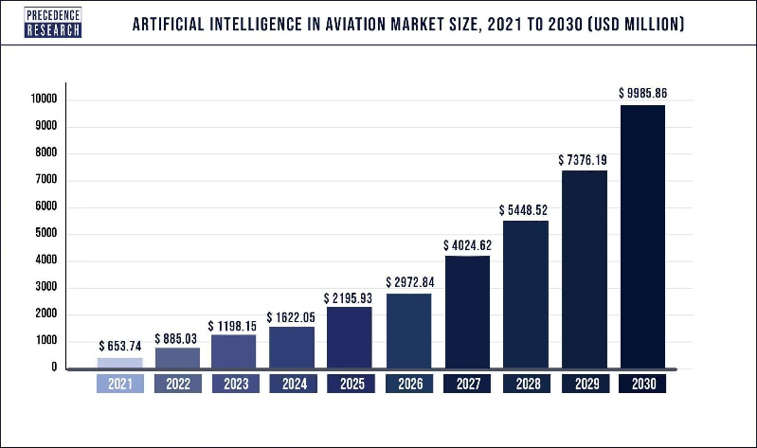

Figure 3: Graphical representation of growth in the field of FIDS

1. **LITERATURE SURVEY**

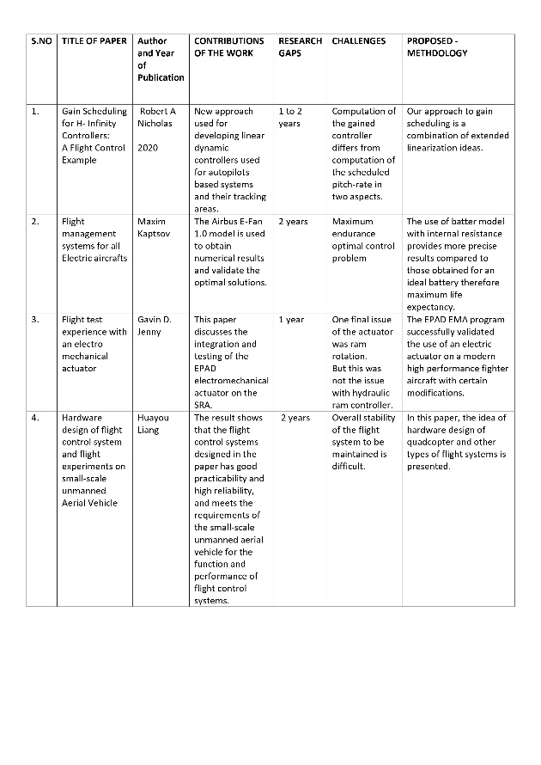

[5] Another notable advancement is the use of artificial intelligence (AI) algorithms in FIDS, which can analyse and predict flight patterns and disruptions, providing more accurate and timely information to passengers. Overall, these advancements in FIDS have greatly improved the efficiency and effectiveness of flight information communication, [6] enhancing the overall passenger experience. In recent years, there have been significant advancements in flight information display systems (FIDS) that have revolutionized the way air travel information is communicated. These digital signs can provide real-time flight updates, gate information, and even weather conditions in a visually engaging format. [7] Additionally, FIDS now integrate with mobile apps and websites, allowing passengers to access flight information conveniently on their smartphones or tablets. [8] This connectivity also enables airlines to push notifications directly to passengers, notifying them of any changes or delays to their flights.

Since most information is presented in a graphical way, it can intuitively be seized by the pilots. Especially in phases of high work-load, the highly pre-processed information and its redundant presentation will significantly contribute to assure pilots situation awareness both in the air and on the ground. [8] We propose an off-axis flight vision display system design with a free-form surface using machine learning to simulate the visual distance variation during take-off and landing training for pilots. This design is realized by ray tracing using ZEMAX software, where we build and optimize a series of initial systems that meet the corresponding optical specifications. A deep neural network is used to train the regression model, which is specifically designed to predict the fitted polynomial model for the free-form surface of the system. Our results demonstrate that the design of a flight visual display system can be transformed into a machine learning problem and further optimized by training and learning with abundant data, providing an avenue to design more powerful and complex imaging optical systems. [9]

[10] We propose an off-axis flight vision display system design with a free-form surface using machine learning to simulate the visual distance variation during take-off and landing training for pilots. This design is realized by ray tracing using ZEMAX software, where we build and optimize a series of initial systems that meet the corresponding optical specifications. A deep neural network is used to train the regression model, which is specifically designed to predict the fitted polynomial model for the free-form surface of the system. Our results demonstrate that the design of a flight visual display system can be transformed into a machine learning problem and further optimized by training and learning with abundant data, providing an avenue to design more powerful and complex imaging optical systems.

[11] We propose an off-axis flight vision display system design with a free-form surface using machine learning to simulate the visual distance variation during take-off and landing training for pilots. This design is realized by ray tracing using ZEMAX software, where we build and optimize a series of initial systems that meet the corresponding optical specifications. A deep neural network is used to train the regression model, which is specifically designed to predict the fitted polynomial model for the free-form surface of the system. Our results demonstrate that the design of a flight visual display system can be transformed into a machine learning problem and further optimized by training and learning with abundant data, providing an avenue to design more powerful and complex imaging optical systems.

[12] While the Navigation System has to provide information about current position, attitudes, and sensor integrity, the databases provide information for terrain, obstacles, airports and navigation aids. [13] Distributed cognition is a useful approach to study the interaction between agents (humans or artefacts) in a system, such as the collaboration involved in air traffic control. When taking a distributed cognition perspective, information processing can be directly observed. This provides the opportunity to explore how information moves through a system, and to identify specific areas where (pervasive) technology can be introduced. However, the analysis involved cannot be simply used “off-the-shelf” and must be tailored to a

specific scenario. Furthermore, the amount of time spent conducting the analysis is often quite significant. This motivates the need for a software tool to support this kind of analysis; to guide the researcher, and reduce the amount of time spent on analysis. This paper presents a prototype of such a tool.

[14] To restrain the negative effects of bounded disturbances, a nonlinear DTDO is designed. Then, a backstepping technique-based ANC strategy is proposed by utilizing a constructed auxiliary system and a discrete-time tracking differentiator. The boundness of all signals is proven in the closed-loop system under the discrete-time Lyapunov analysis. Finally, the feasibility of the proposed ANC technique is further specified based on numerical simulation results.

To restrain the negative effects of bounded disturbances, a nonlinear DTDO is designed. Then, a backstepping technique-based ANC strategy is proposed by utilizing a constructed auxiliary system and a discrete-time tracking differentiator. The boundness of all signals is proven in the closed-loop system under the discrete-time Lyapunov analysis. Finally, the feasibility of the proposed ANC technique is further specified based on numerical simulation results. [15]

[16] Over the past forty years, the number of fighters aircraft-controlled flight into terrain (CFIT) accidents per flight hour has not improved despite the addition of multiple manual warning systems. The Air Force Research Laboratory (AFRL) has undertaken a program to develop an automatic system that will take over when the pilot can no longer recover the aircraft, perform an automatic recovery and quickly return control to the pilot. It is called the Automatic Ground Collision Avoidance System or Auto GCAS. This system has been successfully demonstrated on a Block 50 F-16 with a digital flight control system as shown in Figure 1 and is transitioning to operational Block 40/50 F-16s. [17] Recent years have marked a significant step forward in the development of all-electric airplanes, some of which have been built and tested recently. This paper proposes an optimal control framework for flight management systems of all-electric aircraft. The optimal control problems of economy mode and maximum endurance will be solved using Portraying’s minimum principle. The economy mode optimization problem corresponds to the minimization of a functional parameterized by a coefficient index that performs a trade-off between the cost of the battery charge and timerelated costs. [18] The speed for maximum endurance, the maximum endurance and the maximum range were obtained as analytical solutions of the parameters. However, the speed for maximum range and the speed for economy mode are the positive real roots of a polynomial equation of order eight, which can easily be obtained numerically. The Airbus E-Fan 1.0 model is used to obtain numerical results and validate the optimal solutions.

[19] The 4D Flight Guidance Displays proposed here, are based on a contact analogue synthetic vision system. On the one hand there is an inside out view" of the actual situation called the Primary might Display (PFD) (Figure lo), on the other a parallel projection including the same features called Navigation Display (ND) or moving map display (Figure The artificial images of the outside world on PFD and ND are extended by virtual elements. For example, a spatial flight path predictor and the predetermined flight path are visualized on the PFD (Figure 10) and permit the pilot to intuitively understand his actual situation and react with foresight. [20] In the design of the PFD much attention has been paid to redundancy of information. There is for example the altitude information during approach phase: The first clue to the present altitude is given by the size in which the grid appears which is rendered on the surface of the terrain.

In contrast to the conventional PFD / ND combination, which can be found in any modem airliner and which provides only the information for flying the aircraft and for navigation, synthetic vision displays assist the crew from gate to gate in all phases of operation [21]. The combination of synthetic vision with the virtual elements predictor and approach corridor allows autonomous precision approaches and landings in adverse weather, even on poorly equipped airports. Terrain and obstacles are always visualized and thus avoidance of them is assured even in low visibility conditions.[22] Air traffic management decisions generally do not require information about the interactions among subsystems inside an aircraft, neither what are the factors influencing an airline’s decision to request new flights or cancelling flights. [23] A similar reasoning can be applied to an aircraft which, despite being activated and ruled by the airline strategy, has a high degree of autonomy when decisions have to be made regarding the flight safety. Additionally, each airport is seen as an autonomous entity which has to control the safe use of its resources, such as runways, taxiways, aprons and boarding gates.

[24] Because of these reasons, it was decided to model three distinct agent classes: airline, aircraft and airport. The passenger will be seen in this case study as passive element, because it is considered that the real time decisions of a flight are not made by passengers. [25] This way, the aircraft with smallest delay coefficient value will have higher landing priority. In the case when the second rule is valid, the flight priorities will be evaluated by considering the flight which has the smallest time available to connection, i.e., the smallest *ai* value. Passengers who have a too long time available for connection (*ai* value greater than 120 minutes) are considered as not having connections to perform. The *Distributed data Agent Service Environment* - DASE, is developed in Java and provides a bunch of data services which harmonically integrates with the JADE multi-agent platform. As so, DASE is part of the multi-agent environment, and is composed by agents. Its services are related with the well-defined and transparent access to distributed data, with efficiency and independence of the multi-agent platform implementation [26]. [27] All the DASE functionality is performed by agents, which allow a highly distributed processing. The most of the DASE agent’s tasks are activated by the client agents, outside DASE and, in this case study, represented by the ATM agents. There are three main agent functional groups in DASE: Kernel, Data Access and Concurrency Control.

[28] The main ATM driver for this software was to optimize the decision-making process for landing clearances, aiming to minimize the passenger connection losses and the flight delays. This, in the ATM domain, is part of the collaborative decision making (CDM) concept, because it requires the airlines making passenger information available, and the airport using this information to control the landing priority. [29] The multi-agent software so far developed and being tested allows a great number of agent deployment combinations. We are preparing a scenario where each of the 8 airport agents will be physically located in a computer node across the Gigabit network, and will manage more than one hundred flights during a simulation run. [30] The Subpar and DASE configurations will be set to achieve an optimal query processing distribution and, possibly, some requirements for the use of a similar software (to be developed) in the real-life air traffic management will be deduced.

1. **METHODOLOGY**

First of all, the complete flight information display system is designed in Python environment with good connectivity of database related to phpMyAdmin with the help of Xampp server.The whole security system is managed through passcode criteria designed in the database with the help of PHP language in order to provide better security concern and also enhances the accuracy of model.The security system is not limited with the usage of passcode criteria it also includes some enhanced feature of trails methods for login attempts with secret passkey for admin login in order to directly manage the complete system. Our FIDS software is created in the Python environment so it contains most of the concepts of HTML, CSS and JAVASCRIPT and many more. Also, this model is able to distinguish between n normal user and admin login with the help of environment verification and passkey.

Instead of creating multiple files with different languages in different folder its easier to create a one simple file in one environment which can easily handle all these files with some database connectivity and important python modules.

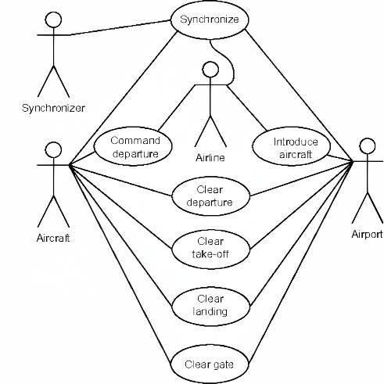

Figure: 4 Use case diagram of flight information display system

In most of the cases it is seen that fight information display system is unable to real time complex scenarios on airports due to lack of feature related to use case implementation so in that case these types of models are able to interact with the real-life scenarios and also able to make changes as per the requirement in order to avoid complex scenarios and ensures smooth process of all system.

In most cases, Flight Information Display Systems (FIDS) are responsible for displaying flight schedules, gate assignments, and any delays or cancellations to passengers. This information is typically pre-programmed and updated manually or through integration with other systems. However, with the rise of AI, FIDS systems can now gather real-time data, analyse it, and provide more accurate and personalized information to passengers. AI also allows for improved airport operations, such as optimizing gate assignments and identifying bottlenecks.

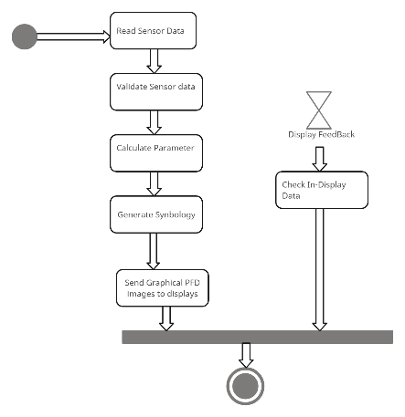

**Figure: 5** Activity diagram of flight information display system

An activity diagram is a visual representation of the flow of activities within a system. In the case of the Flight Information Display System (FIDS), an activity diagram can help illustrate the various steps and interactions involved in displaying flight information to passengers. The diagram typically starts with an initial state, representing the system being in an idle state, waiting for input. The first activity is often triggered by an event, such as a flight schedule update or a passenger request for information. From there, the diagram depicts a series of actions and decisions. For example, the system may need to retrieve updated flight data from a database or an external source. This data can include information such as flight numbers, departure times, arrival times, gate assignments, and any delays or cancellations.

Once the relevant flight information is obtained, the diagram may show how the system processes and organizes this data. This can involve sorting flights by departure time, grouping them by destination, or any other logical organization method.

Next, the diagram illustrates how the system displays the flight information to passengers. This can be through digital displays, mobile apps, or any other medium used within the FIDS. If the system supports personalized updates, the diagram may show how it determines the relevant information for each passenger based on their preferences and travel itinerary. Throughout the diagram, there may be decision points that depend on certain conditions. For example, if there are multiple gate options available for a flight, the system may need to select the most suitable gate based on factors like aircraft size, availability, and airline preferences. Finally, the diagram concludes with an end state, representing the completion of the activities. This can occur once all flight information has been displayed and any necessary updates have been made.Overall, an activity diagram of a Flight Information Display System provides a visual representation of the flow of activities involved in gathering, processing, and displaying flight information to passengers.

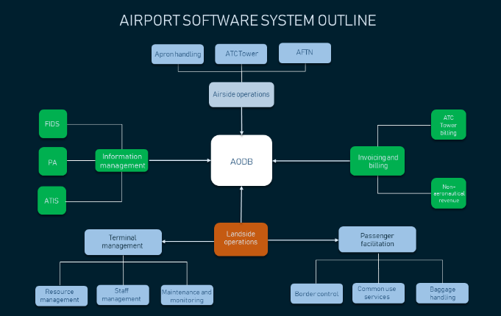

Figure 6: Flow diagram representation different stages of flight information display system

Designing a good Flight Information Display System (FIDS) is essential to ensure that passengers and airport staff receive accurate and up-to-date information. Here are the basic steps to take care of when designing such a system.

**Understand User Needs**: Identify the various user groups, such as passengers, airline staff, airport personnel, and flight crews, and determine their specific information requirements.

**Gather Requirements**: Collaborate with stakeholders to gather detailed requirements for the FIDS, including the types of information to be displayed, the locations of displays, and any regulatory or accessibility requirements.

**User Interface Design**: Design a user-friendly interface that provides clear and concise information. Consider factors such as font size, colours, and layout for readability and accessibility.

**Data Sources and Integration**: Establish connections with data sources, such as airlines, air traffic control, and weather services, to ensure real-time and accurate information. Implement robust integration protocols for data retrieval.

**Data Accuracy and Redundancy**: Implement measures to ensure data accuracy and redundancy. Information should be updated in real-time and backed up to prevent downtime.

**Network Infrastructure**: Ensure a robust and reliable network infrastructure to support data transfer and real-time updates to the displays.

**Emergency Information**: Include provisions for displaying emergency information and alerts. This can include weather warnings, security updates, and evacuation instructions.

**Wayfinding and Signage**: Integrate the FIDS with the airport's wayfinding and signage system to guide passengers to their destinations.

**Accessibility**: Ensure compliance with accessibility standards, including options for visually impaired passengers through text-to-speech functionality and clear visual displays for the hearing impaired.

**Testing and Quality Assurance**: Rigorously test the system to ensure it functions correctly under various conditions, including high traffic periods and emergencies.

**Security Measures**: Implement security measures to protect the system from cyber threats and unauthorized access.

* 1. **TASKS PERFORMED BY FIDS SOFTWARE**

The system focuses on several key areas to manage flights and users securely and efficiently. Authentication of users is a top priority, with features like user login validation, passcode generation and validation, and two factor authentication. The system is connected to a database for storing and retrieving flight details and passenger information. It allows for addition of new flight details as well as updating and deleting existing flight information. Proper database security measures using techniques like timing are implemented. There is a display board feature to show flight information to passengers. Passenger and flight details are stored for future use. Overall, the key functions center around user and data management in a secure manner.

1. **RESULT**
   1. **DISPLAY BOARD IMAGES OF FIDS SOFTWARE**

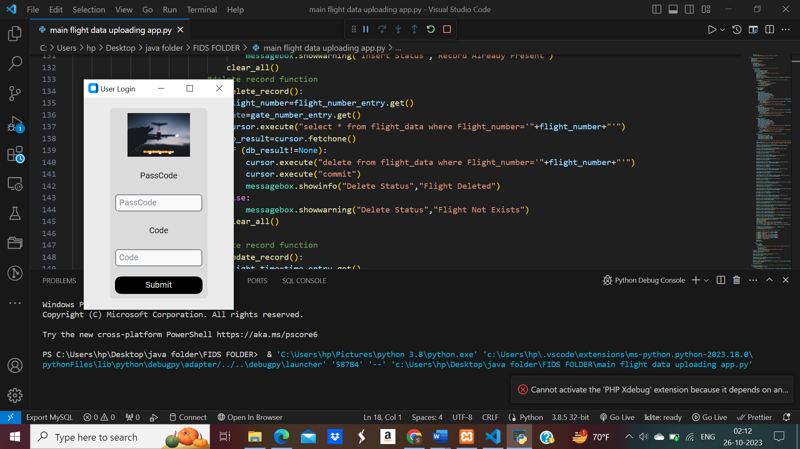

Figure 7: User details validation software with passcode insertion

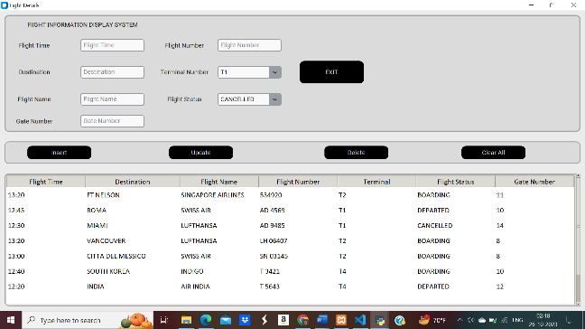

Figure 8: Display board representing the set of opeartions performed on flight details

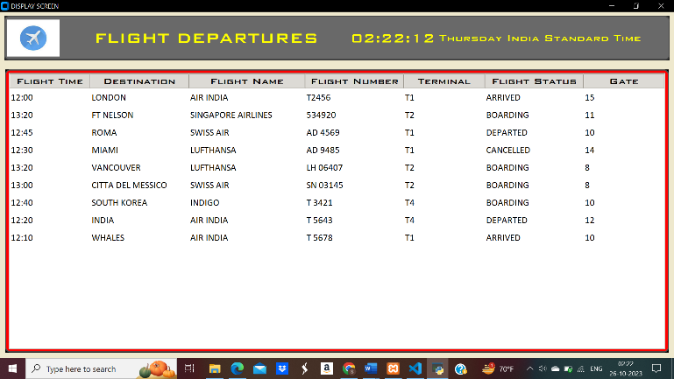

Figure 9: Display board representing the flight details with their flight departures

* 1. **SYSTEM COMPONENTS FOR FIDS SOFTWARE**

1. Windows based operating system.
2. >2GB RAM
3. Python console
4. Python version must be greater than 3.0
5. Desired machine learning environment with pre-defined results.
6. Python modules for performing the machine learning algorithms
7. The system must be compatible with the MySQL connector module in order to access the database and its repositories.
8. The system must include XAMPP SREVER in order to connect with the database and its core components.
9. MySql server must be able to distinguish between the actual user and robot login.
10. **Central Server**: The central server is the core component that manages and processes all the flight data. It collects information from various sources and distributes it to display units throughout the airport.
11. Display boards or units
12. Flight information displays
13. Check-In kiosks
14. Mobile apps and websites

FIDS plays a crucial role in enhancing the passenger experience, improving operational efficiency, and ensuring that passengers have access to the latest information regarding their flights and the airport environment. These components work together to provide accurate and real-time flight information to passengers and airport staff.

* 1. **BASIC CHALLENGES FACED IN FLIGHT INFORMATION DISPLAY SYSTEM**

Data security and integration: Fids relies on accurate data from various sources, including airlines, air traffic control and weather services. Integrating this data in real-time can be a challenge, and inaccuracies can lead to confusion and challenges.

Data security: Ensuring the security of data displayed is crucial.

Scalability: Airports are growing in size and capacity. FIDS must be scalable to accommodate the increasing number of flights and passengers while maintaining performance.

User Experience: Designing FIDS displays that are clear and easy to understand is crucial. Passengers come from diverse backgrounds and may not be familiar with airport operations.

Multilingual support: Airports serve a global audience. Providing information in multiple languages is essential for ensuring that all passengers can understand and use the system.

1. **CONCLUSION**

In conclusion, the Flight Information Display System (FIDS) plays a pivotal role in the smooth and efficient functioning of airports, serving as the primary interface for passengers and airport personnel to access critical flight information. However, this essential system is not without its challenges. The contemporary aviation landscape demands a high degree of data accuracy, security, and integration, as airports continue to grow in size and complexity. Redundancy and resilience are critical to maintaining operational continuity in the face of system failures. The user experience, accessibility, and multilingual support have become paramount, given the diverse passenger base of global airports. Furthermore, the need for real-time updates, adaptation to new technologies, and compliance with ever-evolving regulations all present ongoing hurdles. The cost implications and sustainability concerns cannot be ignored, as airports strive to balance providing accurate information with financial prudence and eco-consciousness. In light of these challenges, FIDS providers and airport operators must remain committed to innovation, continuous improvement, and collaboration with relevant stakeholders to ensure that FIDS continues to meet the dynamic needs of the aviation industry while enhancing the passenger experience and maintaining a secure, reliable, and environmentally responsible presence in airports worldwide.

* 1. **FUTURE SCOPE**

Main future scope of this model is to generate the required result on time with proper accuracy and enhanced security. Secondly, the main purpose of this software is to deal with the database records in order to present them in the database. In the third most important process its necessary to deal with the security measures on time in order to prevent the unwanted access to the database and its records. IOT Integration, customization and personalization.

1. **REFERENCES**

*[1] S. Moran and K. Nakata , “A Distributed Cognition Based Tool for Information Trajectory Analysis ,” in ACM International Conferences on Web Intelligence and Intelligent Agent Technology, IEEE, Oct. 2011.*

*[2] S. Shao, M. Chen, and Y. Zhang, “Adaptive Discrete-Time Flight Control Using Disturbance Observer and Neural Networks,” IEEE transactions on neural networks and learning systems, vol. 30, no. 12, pp. 3708–3721, Dec. 2019, doi: https://doi.org/10.1109/tnnls.2019.2893643.*

*[3] K. A. Klein, H. Eckberg, and R. H. Dean, “An analysis of low-cost simulated flight management systems for aviation research,” Oct. 2009, doi: https://doi.org/10.1109/dasc.2009.5347569.*

*[4] Ngoc Phu Tran, D.-T. Pham, Sim Kuan Goh, S. Alam, and V. Duong, “An Intelligent Interactive Conflict Solver Incorporating Air Traffic Controllers’ Preferences Using Reinforcement Learning,” 2019 Integrated Communications, Navigation and Surveillance Conference (ICNS), Apr. 2019, doi: https://doi.org/10.1109/icnsurv.2019.8735168.*

*[5] A. Burns, D. Harper, A. F. Barfield, S. Whitcomb, and B. Jurusik, “Auto GCAS for analog flight control system,” 2011 IEEE/AIAA 30th Digital Avionics Systems Conference, Oct. 2011, doi: https://doi.org/10.1109/dasc.2011.6096148.*

*[6] R. A. Nichols, R. T. Reichert, and W. J. Rugh, “Gain scheduling for H-infinity controllers: a flight control example,” IEEE Transactions on Control Systems Technology, vol. 1, no. 2, pp. 69–79, Jun. 1993, doi: https://doi.org/10.1109/87.238400.*

*[7] M. Kaptsov and L. Rodrigues, “Flight management systems for all-electric aircraft,” IEEE Xplore, Aug. 01, 2017. https://ieeexplore.ieee.org/abstract/document/8062767 (accessed Mar. 12, 2023).*

*[8] S. C. Jensen, G. D. Jenney, and D. M. Dawson, “Flight test experience with an electromechanical actuator on the F-18 Systems Research Aircraft,” Document Analysis Systems, Jan. 2000, doi: https://doi.org/10.1109/dasc.2000.886914.*

*[9] X. Yin, K. Xu, H. Liang, G. Zhang, X. Peng, and Q. Zhang, “Hardware Design of Flight Control System and Flight Experiments of Small-Scale Unmanned Aerial Vehicle,” IEEE Conference Paper, Aug. 2020, doi: https://doi.org/10.1109/ccdc49329.2020.9164578.*

*[10] M. Karpenko and N. Sepehri, “Hardware-in-the-loop simulator for research on fault tolerant control of electrohydraulic actuators in a flight control application,” Mechatronics, vol. 19, no. 7, pp. 1067–1077, Oct. 2009, doi: https://doi.org/10.1016/j.mechatronics.2009.01.008.*

*[11] Phạm Minh Đức et al., “HoanKiemAir: simulating impacts of urban management practices on traffic and air pollution using a tangible agent-based model,” HAL (Le Centre pour la Communication Scientifique Directe), Oct. 2020, doi: https://doi.org/10.1109/rivf48685.2020.9140787.*

*[12] R. de, F. Carvalho, J. Batista Camargo, and Liria Matsumoto Sato, “Multi-Agent Tools for Air Traffic Management,” Computational Science and Engineering, Jul. 2008, doi: https://doi.org/10.1109/csew.2008.46.*

*[13] M. Bodson and J. E. Groszkiewicz, “Multivariable adaptive algorithms for reconfigurable flight control,” IEEE Transactions on Control Systems Technology, vol. 5, no. 2, pp. 217–229, Mar. 1997, doi: https://doi.org/10.1109/87.556026.*

*[14] G. Campa, Mario Luca Fravolini, M. Napolitano, and B. Seanor, “Neural networks-based sensor validation for the flight control system of a B777 research model,” Jun. 2003, doi: https://doi.org/10.1109/acc.2002.1024840.*

*[15] Fang Liao, Jian Liang Wang, and Guang-Hong Yang, “Reliable robust flight tracking control: an LMI approach,” IEEE Transactions on Control Systems Technology, vol. 10, no. 1, pp. 76–89, 2002, doi: https://doi.org/10.1109/87.974340.*

*[16] Z. Song, “Research and Implementation of Simulation System for Flight Multi-Function Display,” Computer Simulation, Jan. 2004.*

*[17] P. Lu, Laurens Van Eykeren, E. van Kampen, Coen, and Q. P. Chu, “Aircraft Inertial Measurement Unit Fault Identification with Application to Real Flight Data,” IEEE conference , vol. 38, no. 12, pp. 2467–2475, Dec. 2015, doi: https://doi.org/10.2514/1.g001247.*

*[18] Ayad Al-Mahturi, F. Santoso, M. Garratt, and S. G. Anavatti, “Self-Learning in Aerial Robotics Using Type-2 Fuzzy Systems: Case Study in Hovering Quadrotor Flight Control,” Scopus, vol. 9, pp. 119520–119532, Jan. 2021, doi: https://doi.org/10.1109/access.2021.3107906.*

*[19] G. Silano, P. Oppido, and L. Iannelli, “Software-in-the-loop simulation for improving flight control system design: a quadrotor case study,” IEEE Confernce paper , Oct. 2019, doi: https://doi.org/10.1109/smc.2019.8914154.*

*[20] E. Crück and J. Lygeros, “Subliminal air traffic control: Human friendly control of a multi-agent system,” Proceedings of the ... American Control Conference, Jul. 2007, doi: https://doi.org/10.1109/acc.2007.4282641.*

*[21] C. H. Acton, “Ancillary data services of NASA’s Navigation and Ancillary Information Facility,” Planetary and Space Science, vol. 44, no. 1, pp. 65–70, Jan. 1996, doi: https://doi.org/10.1016/0032-0633(95)00107-7.*

*[22] H. Yao, “The Realization of Flight Simulation System Based on OpenGL,” IEEE paper , Jul. 2010, doi: https://doi.org/10.1109/itcs.2010.55.*

*[23] Wolfgang Kubbat, Peter Marcus Lenhart, and Harro von Viebahn, “4D flight guidance displays, a gate to gate solution,” Nov. 2002, doi: https://doi.org/10.1109/dasc.1998.741594.*

*[24] S. Mao, Z. Ren, and J. Zhao, “An off-axis flight vision display system design using machine learning,” IEEE Photonics Journal, vol. 14, no. 2, pp. 1–6, Apr. 2022, doi: https://doi.org/10.1109/jphot.2022.3155250.*

*[25] J. L. Garloch, “Flight testing of a prototype Cockpit Display of Traffic Information for approach spacing applications,” Nov. 2002, doi: https://doi.org/10.1109/dasc.2001.963387.*

*[26] C. W. Reynolds, “Flocks, herds and schools: A distributed behavioral model,” ACM SIGGRAPH Computer Graphics, vol. 21, no. 4, pp. 25–34, Aug. 1987, doi: https://doi.org/10.1145/37402.37406.*

*[27] C. A. Wargo, G. C. Church, J. Glaneueski, and M. Strout, “Unmanned Aircraft Systems (UAS) research and future analysis,” IEEE Xplore, Mar. 01, 2014. https://ieeexplore.ieee.org/abstract/document/6836448/citations?tabFilter=papers#citations (accessed May 02, 2022).*

*[28] J. E. Prussing, “Geometrical Interpretation of the Angles CY and B in Lambert’s Problem,” Journal of guidance and control, vol. 2, no. 5, pp. 442–443, Sep. 1979, doi: https://doi.org/10.2514/3.55905.*

*[29] I. Flight, Flight Test Instrumentation; Proceedings. 1965.*

*[30] “Flight Journal - Aviation History | History of Flight | Aviation History Articles, Warbirds, Bombers, Trainers, Pilots,” Flight Journal. https://www.flightjournal.com/*